# LAB-ASSIGNMENT 4.3

**MD ZIAUDDIN**

**2403A51271**

Task Description#1

* Zero-shot: Prompt AI to write a function that checks whether a given year is a leap year.

Expected Output#1

* AI-generated function with no examples provided

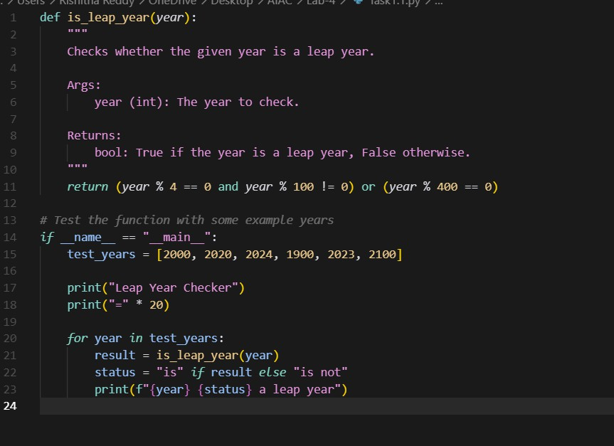

OUTPUT:

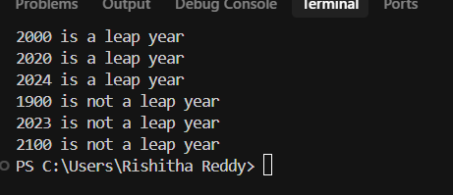

Task Description#2

* One-shot: Give one input-output example to guide AI in writing a function that converts centimeters to inches.

Expected Output#2

* Function with correct conversion logic
* 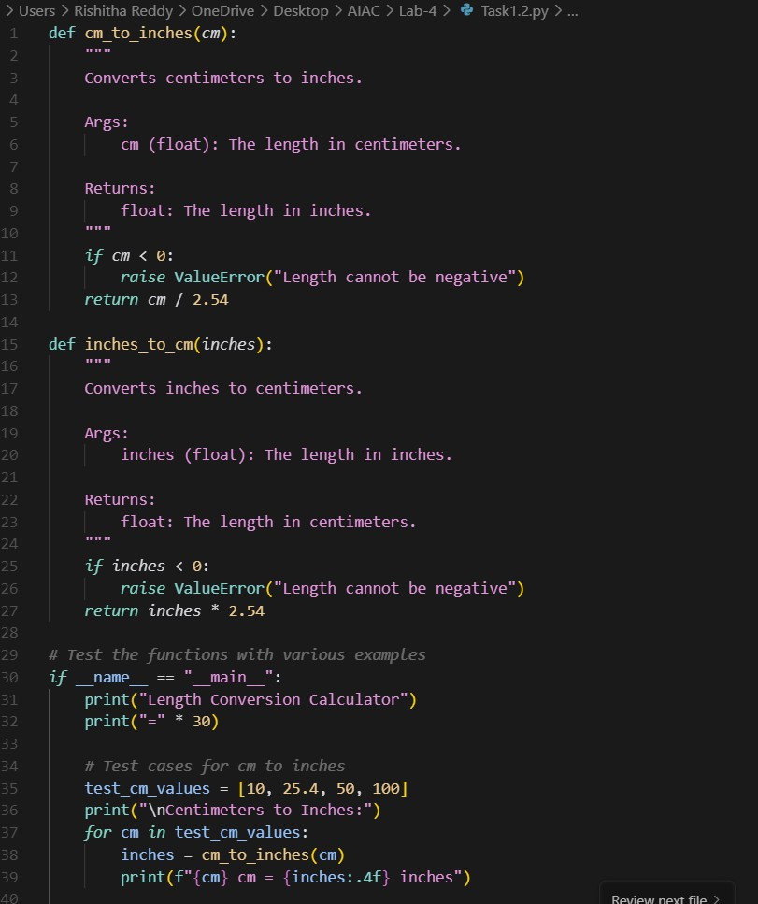

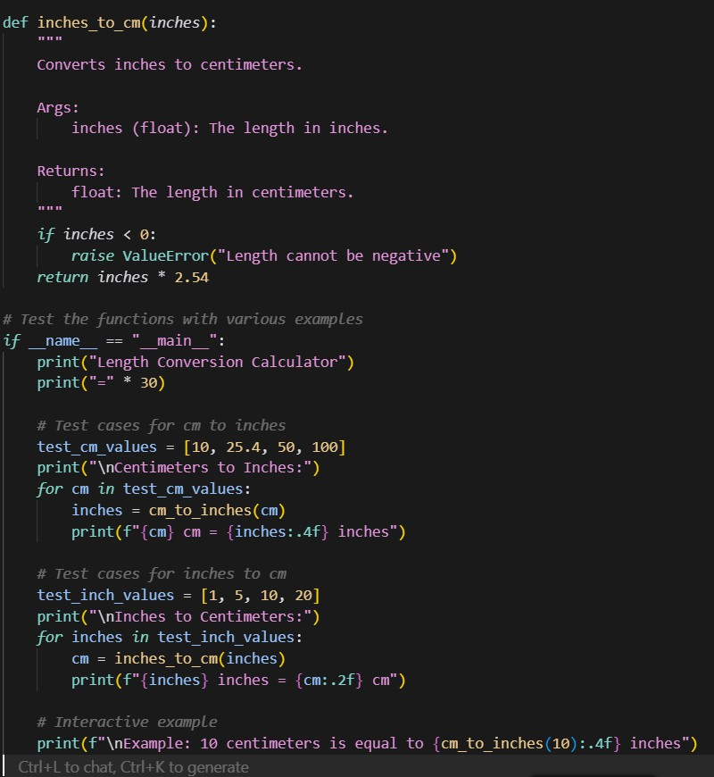

# OUTPUT:

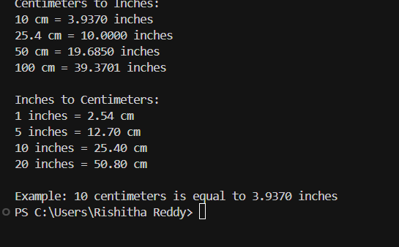

Task Description#3

* **Few-shot: Provide 2–3 examples to generate a function that formats full names as “Last, First”.**

Expected Output#3

Well-structured function respecting the examples

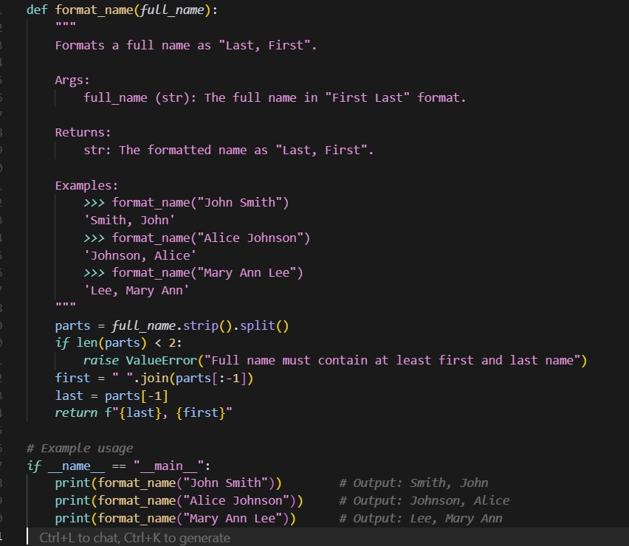

OUTPUT:

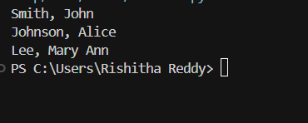

Task Description#4

* Compare zero-shot and few-shot prompts for writing a function that counts the number of vowels in a string.

Expected Output#4

* Functional output and comparative reflection
* 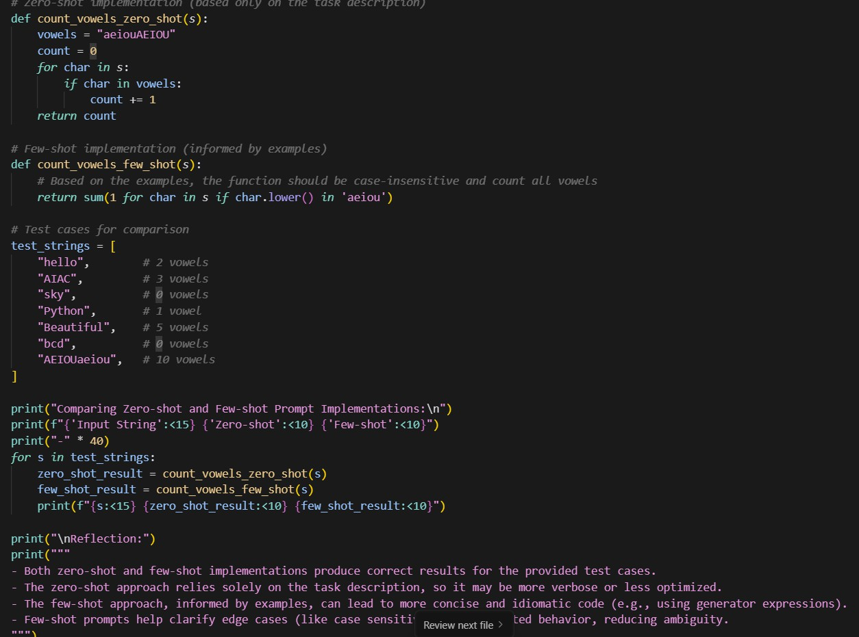

# OUTPUT:

* 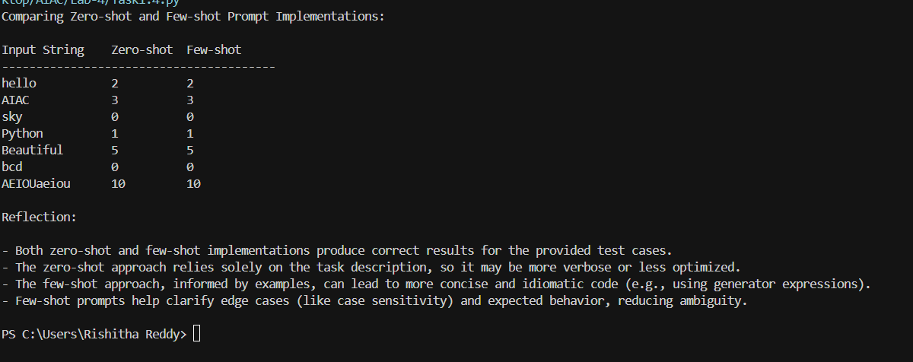

Task Description#5

* **Use few-shot prompting to generate a function that reads a .txt file and returns the number of lines.**

Expected Output#5

* **Working file-processing function with AI-guided logic**
* 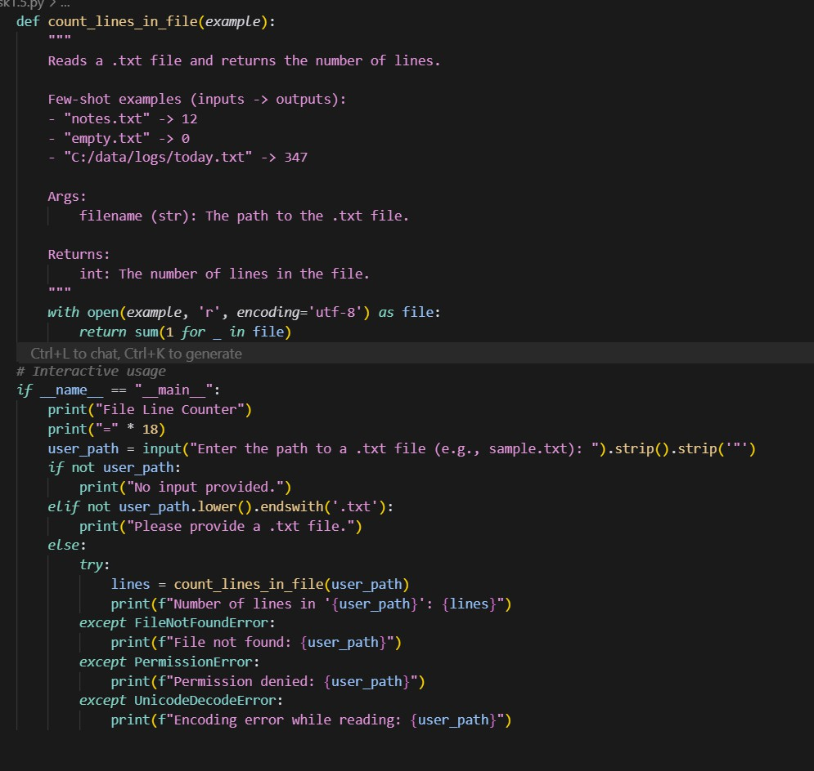

**OUPTUP:**

